

Capstone Project Report
Report 2 – Project Management Plan

– Hanoi, August 2019 –
Table of Contents
I. Record of Changes 3
II. Project Management Plan 4
1. Overview 4
1.1 Scope & Estimation 4
1.2 Project Objectives 4
1.3 Project Risks 4
2. Management Approach 5
2.1 Project Process 5
2.2 Quality Management 5
2.3 Training Plan 5
3. Project Deliverables 5
4. Responsibility Assignments 5
5. Project Communications 6
6. Configuration Management 6
6.1 Document Management 6
6.2 Source Code Management 6
6.3 Tools & Infrastructures 6

I. Record of Changes
Date | A*  M, D | In charge | Change Description
*A - Added M - Modified D - Deleted

II. Project Management Plan

1. Overview

1.1 Scope & Estimation
[Create/Provide the list of software product following the table template as below. In this table, we categorize each software function into three levels of complexity (Simple, Medium, Complex) and estimate the total effort to complete each one in man-day]
# | WBS Item | Complexity | Est. Effort  (man-days)
1 | Core Football Data Management |  | 21
1.1 | League & Season Setup (Vietnam Leagues only) | Simple | 4
1.2 | Team & Player Management | Medium | 7
1.3 | Match & Player Statistics Management | Complex | 10
2 | Player Performance Rating System |  | 22
2.1 | Match-based Player Statistics Calculation | Medium | 7
2.2 | Player Rating Formula Engine | Complex | 10
2.3 | Rating Explanation & Breakdown | Medium | 5
3 | Fan Interaction & Community Engagement |  | 18
3.1 | Fan Voting System (Best Player, Top Scorer) | Medium | 7
3.2 | Match Prediction System | Medium | 6
3.3 | Event & Giveaway Management | Simple | 5
4 | AI-assisted Analysis & Content Generation |  | 20
4.1 | AI-based Match Summary Generation | Medium | 6
4.2 | Player Insight Generation from Statistics | Medium | 5
4.3 | Video-based Match Situation Analysis (PoC) | Complex | 9
5 | User & Subscription Management |  | 10
5.1 | User Registration & Authentication | Simple | 4
5.2 | Subscription Package Management | Medium | 6
6 | UI/UX & System Integration |  | 36
6.1 | Frontend UI Development | Simple
6.2 | API Integration & Testing | Simple
Total Estimated Effort (man-days) |  |  | 103

1.2 Project Objectives
[Provide the overall project objective description and then the specific target metrics of your project in term of quality, time, and cost (allocated effort distribution for project activities: requirement, design, coding, testing, project management, etc). For example
Quality
# | Testing Stage | Test Coverage | No. of Defects | % of Defect | Notes
1 | Reviewing | 100% documents | ≤5 | <5% | Peer review
2 | Unit Test | ≥70% | ≤10 | <10% | Backend focus
3 | Integration Test | ≥60% | ≤8 | <10% | API + Frontend
4 | System Test | ≥80% | ≤5 | <5% | End-to-end
5 | Acceptance Test | Key features | ≤3 | <3% | Supervisor review

Milestone Timeliness (%): ≥ 90%
Allocated Effort (man-days): ~85 man-days
]

1.3 Project Risks
[List out the details on project risks in the table below]
# | Risk Description | Impact | Possibility | Response Plans
1 | AI tools not fully accurate | Medium | Medium | Use AI as support, not decision-maker
2 | Lack of real match data | High | Medium | Use simulated / public datasets
3 | Scope creep | High | Low | Freeze scope after SRS
4 | Team skill gap in AI | Medium | Medium | Use pre-trained models / APIs
5 | Time shortage | High | Medium | Prioritize core features

2. Management Approach
[Describe the approach you would use the manage and implement your project]

2.1 Project Process
[Draw and describe the software development process model that the team would apply into the project implementation]
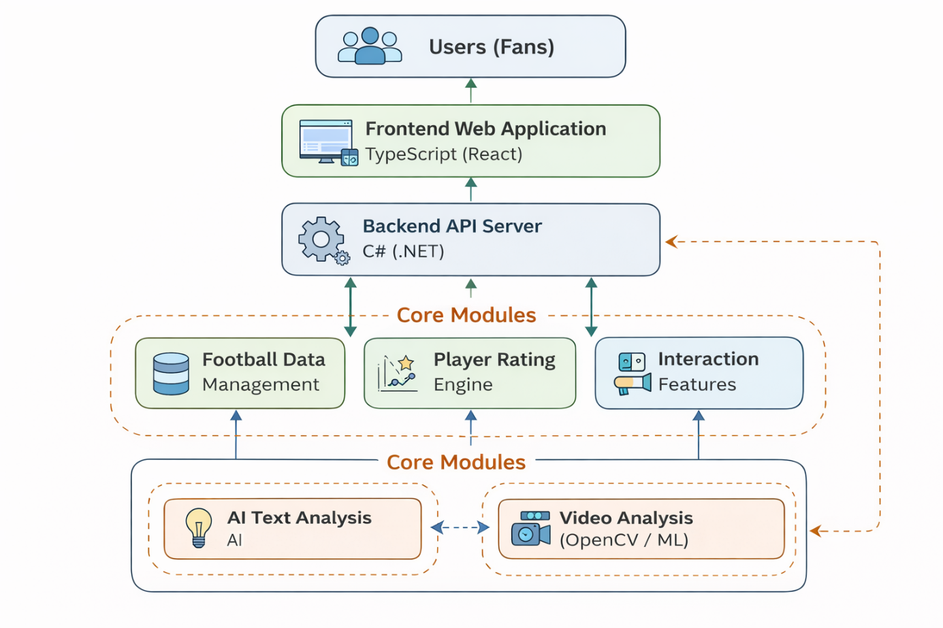

2.2 Quality Management
[Provide the approach you would apply to improve the project quality, reach the project quality objectives. Some of the quality approach can include
- Defect Prevention: coding standards, design review
- Reviewing: weekly peer review
- Unit Testing: backend APIs
- Integration Testing: frontend + backend
- System Testing: full user flows
]

2.3 Training Plan
[You need to plan the training activities in case any of your team member lack of knowledge/skills to handle the project works]
Training Area | Participants | When, Duration | Waiver Criteria
TypeScript | Thiên Ân + Thiên Duy | Week 1 | Basic frontend
C# / ASP.NET Core | Tấn Trung + Minh Phúc | Week 1-2 | API knowledge
Git/GitHub | All members | Week 1 | Mandatory
AI tools (Gemini) | AI Gemini | Week 3 | Proof-of-concept

3. Project Deliverables
[Given the main project deliverables. Those can be internal and/or external deliverables. Students can prepare master schedule like the table format as below or in the more detailed structure as the sample in the attached sample file - Report2_Sample High Level Project Schedule.pdf]
# | Deliverable | Due Date | Notes
1 | Project Proposal | dd/MM/yyyy | Approved
2 | SRS Document |  | Revised
3 | System Design (ERD, UML) |  | Final
4 | Source Code |  | Git repo
5 | Testing Report |  | Included
6 | Final Capstone Report |  | PDF
7 | Presentation Slides |  | Defense

4. Responsibility Assignments
[Describe the main responsibilities in your project (to complete the outputs as defined in the above section), in the format as the sample below]
D~Do; R~Review; S~Support; I~Informed; <blank>- Omitted
Responsibility | TrungHT SE180467 | PhucHM SE183572 | AnNPTSE171081 | DuyNT SE182230
Project Planning & Tracking | D | D | D | D
Prepare Project Introduction Document | D | S | S | S
Prepare SRS Document (Overview Part)
Prepare SRS Document (User Requirements)
Requirement Analysis | D | D | D | D
Backend Development | D | D | R | R
Frontend Development | R | R | D | D
AI Integration | D | D | R | R
Testing | D | D | D | D
Documentation | D | D | D | D

5. Project Communications
Communication Item | Who/ Target | Purpose | When, Frequency | Type, Tool, Method(s)
Mentor Review | Team + Mentor | Feedback | Weekly | FPTU
Weekly Meeting | Team | Progress | Weekly | Google Meet
Internal Chat | Team | Daily sync | Daily | Zalo

6. Configuration Management

6.1 Document Management
[Describe how you would manage project documents & their changes/versions]
- Google Drive
- Version naming: v1.0, v1.1

6.2 Source Code Management
[Describe how you would manage project source codes & their changes/versions]
- GitHub
- Branch strategy: main / dev / feature

6.3 Tools & Infrastructures
Category | Tools / Infrastructure
Technology | TypeScript (FrontEnd), Android (App), C#, ASP.NET Core (BackEnd)
Database | SQL Server, FireBase
IDEs/Editors | Visual Studio Code
Diagramming | StarUML, DrawIO
Documentation | Ms Office, Google Docs/Sheets/Slides
Version Control | GitLab (Source Codes), Google Drive (Documents)
Deployment server | Amazon Web Service
Project management | ProjectLibre (Schedule), GitLab (Tasks, Defects)

